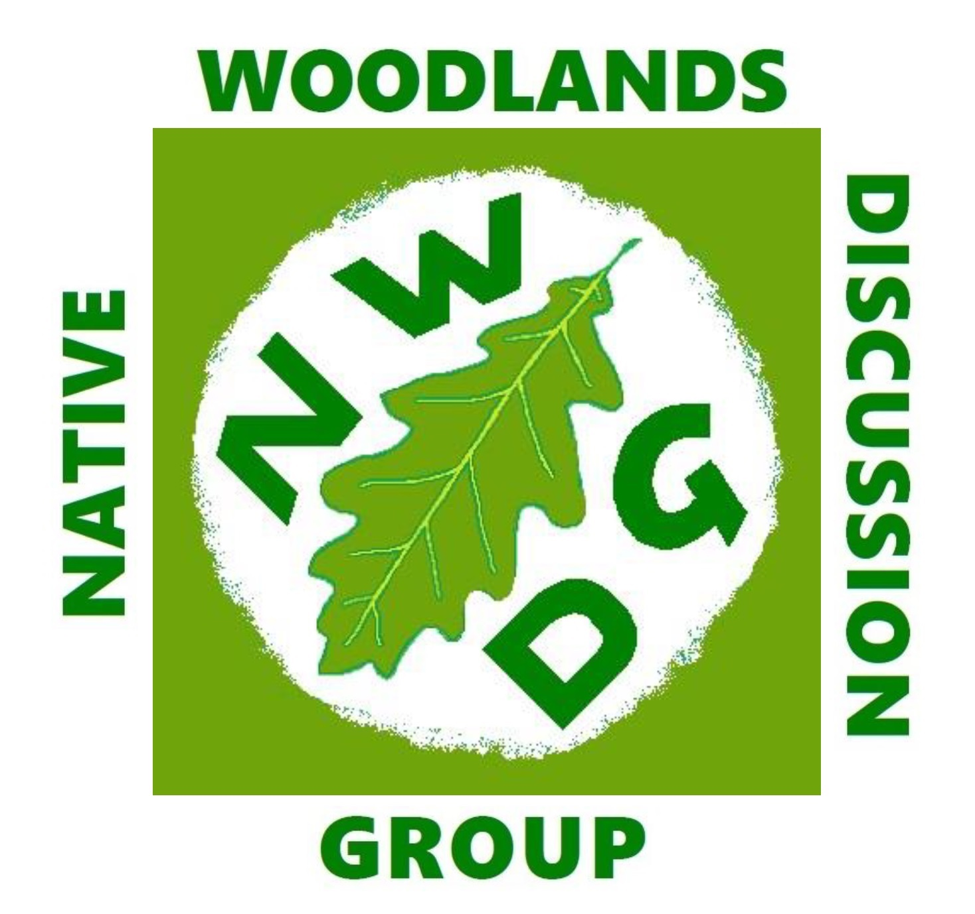
NATIVE WOODLANDS DISCUSSION GROUP
Membership form for 2025

Please fill in and post to Adam Samson, 6 Buchanan Crescent, Croftamie, Drymen, G63 0ET or sign & scan/ sign electronically and email to adam.samson6@gmail.com

You may pay either by cheque made payable to ‘Native Woodlands Discussion Group’, by BACS (bank details below) or by Standing Order.

Subscription rates: Ordinary £20; Family £30; People under 25 years £12
All rates are discounted by £2 if paying by standing order

NAME:............................................................................................………………................................

ADDRESS:...........................................................................................………………...........................

...................................................................………...... Post code:...........………..........................

TEL:.................................................................. E-MAIL:.............................................................

How did you hear about the NWDG? Website………..Facebook……………Twitter………Friend or colleague………Other………………………………………………………………………………………

I AM PAYING BY CHEQUE AND ENCLOSE A CHEQUE FOR £ ............................
(Payable to ‘Native Woodland Discussion Group’)

I HAVE PAID BY BACS AND MY REFERENCE IS………………………………………
Native Woodland Discussion Group; A/C no. 40218108; Sort Code 82-66-11; Business Account

I AM PAYING BY STANDING ORDER and have set this up with my bank myself or completed and signed the standing order form below (please delete accordingly)

GDPR and data privacy: I agree that the information on this form can be entered in the NWDG database and my email and postal addresses used for NWDG correspondence, but I understand that it will not be used for any purpose other than NWDG administration nor passed to third parties.

SIGNED: ...................................................................................... DATE:...............................................

Paying by Standing Order

NAME OF YOUR BANK.............................................................................................................................................

YOUR BANK’S ADDRESS.........................................................................................................................................

SORT CODE ...................... ACCOUNT NAME..............................................ACCOUNT NUMBER..........................

Please pay the Native Woodland Discussion Group A/C no. 40218108, Sort Code 82-66-11 Virgin Money

The sum of £...........................annually. Please make the first payment now and subsequent payments on 15th January annually until further notice.

Signed: .......................................................................................... Date: .......................................................

Please note that if you send this form by email the signature needs to be your actual signature, not just your printed name, as your bank needs to be able to tell that it is really you setting up the payment. Thanks very much.

